TITLE: POSTER CREATION

USER NAME: 1B2F893465B7584B39544A589B539B36

1.Open canva App

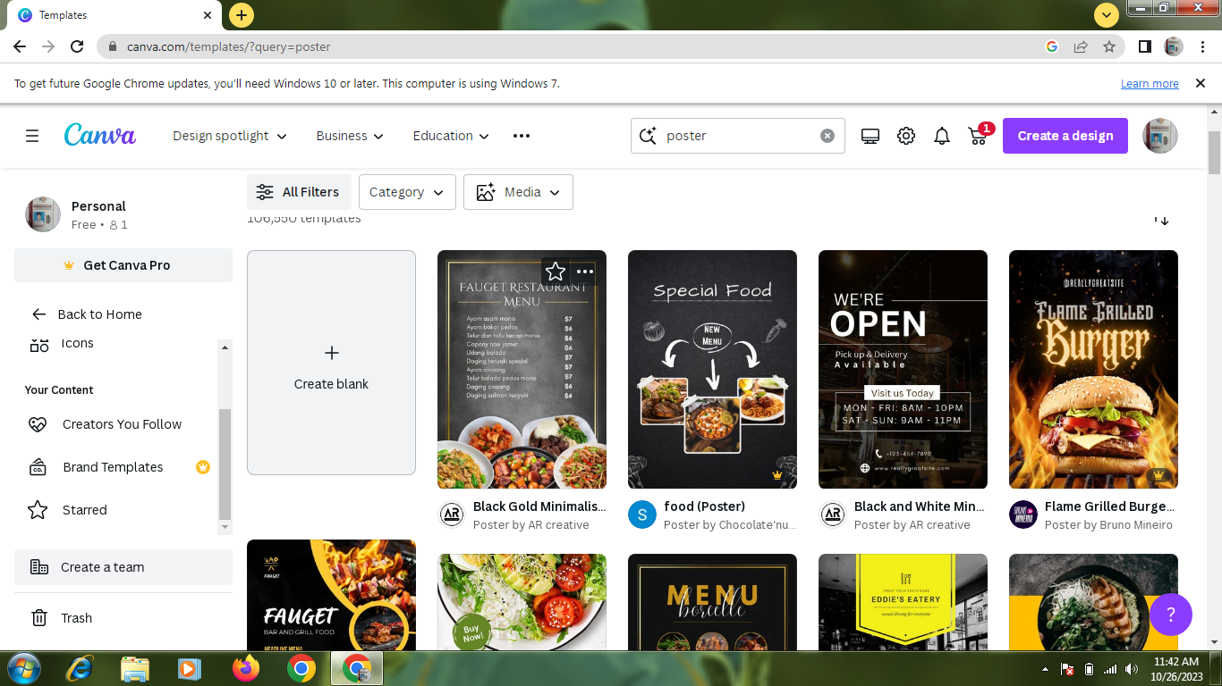

2. select a template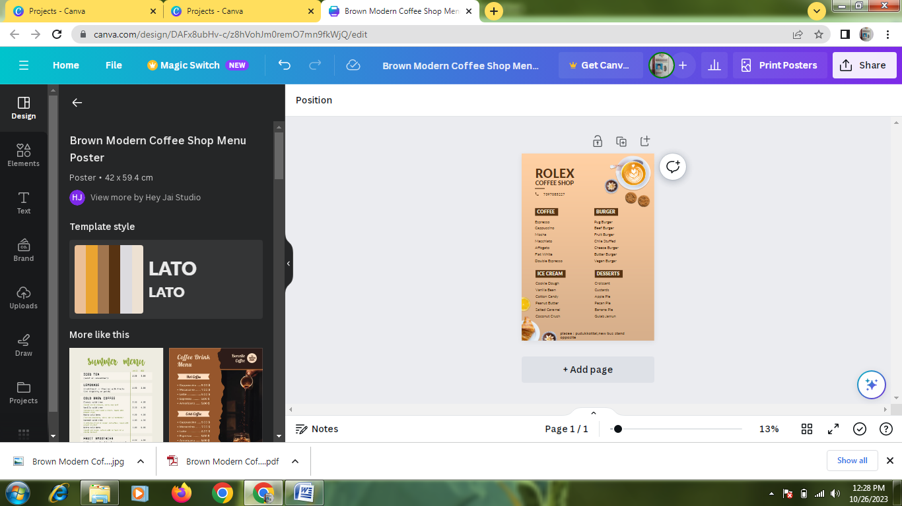

3.Edit a details

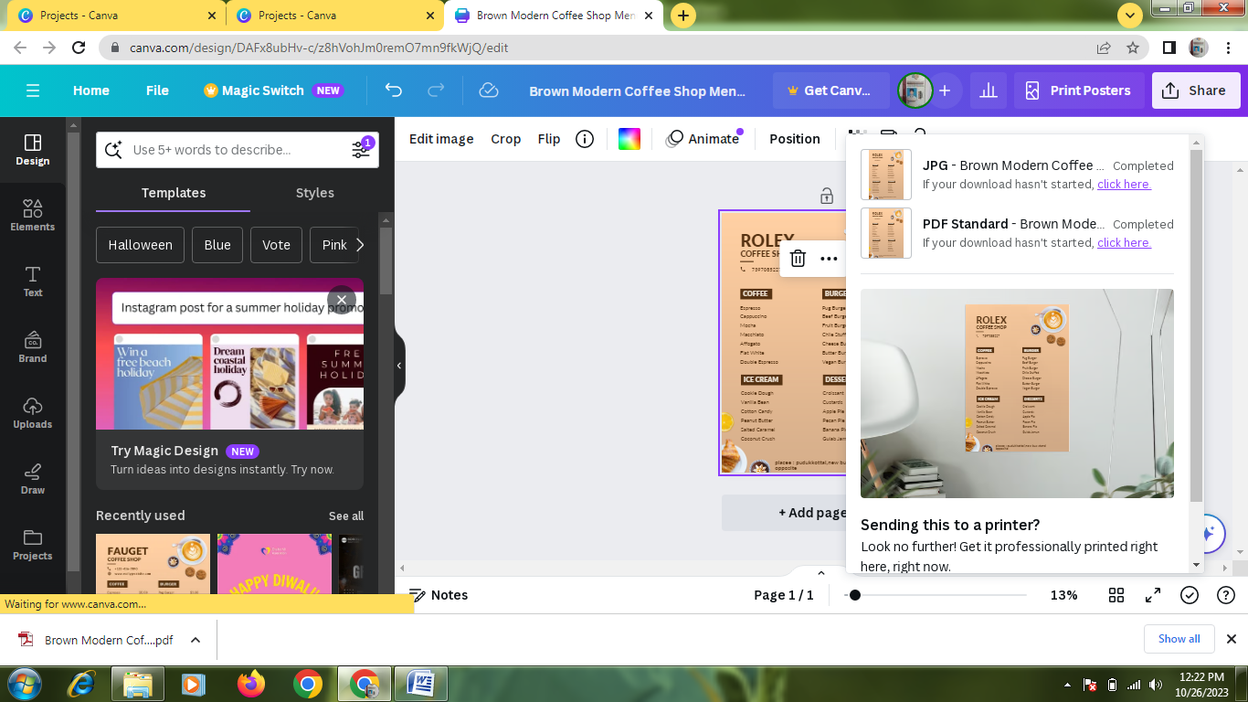

4.Upload a business related image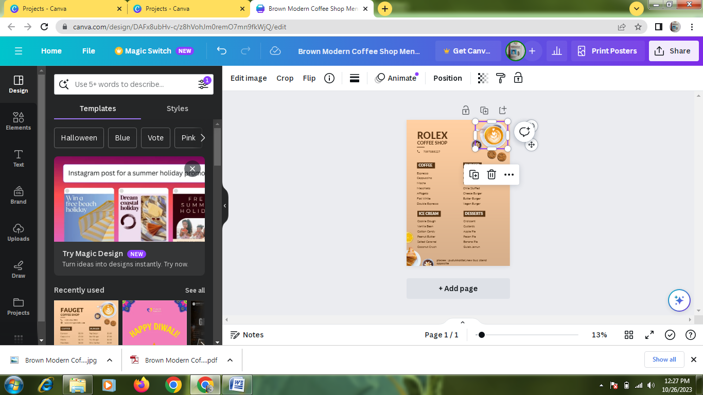

5.Pdf convert

